New Hampshire Association of Special Education Administrators
Professional Learning Opportunities Go Virtual!
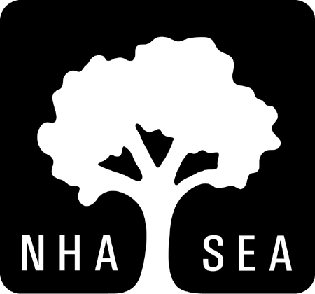
As We Embark on What Will Be a Very Unusual School Year, Join NHASEA for Some Incredible Virtual Professional Learning Opportunities
These are unprecedented times for educators. Together, everyone in the special education field must use our collective strength to overcome these new significant challenges. At NHASEA, our strengths include planning ahead and finding opportunities to support our members and their colleagues in order to persevere through these difficult times. As we re-enter a new school year, many things remain unknown, but our professional learning offerings for this year are meant to help us all evolve and grow together. Below you will find our offering for Special Education Building Coordinators. If you are interested in participating in this offering, please complete the attached registration form and return dlavoie@nhasea.org or ahorrocks@nhasea.org. Thank you.
Special Education Building Coordinators PLC
As special education building coordinators rally to respond to COVID-19, and leading at the building level, NHASEA is committed to supporting you! Join Special Education Building Coordinators as they focus upon collective learning, networking, and collegial support by sharing and learning centered on best practices. This PLC meets regularly to:
- Improve skills and knowledge of Special Education building level leaders through collaborative study, exchange of expertise and professional dialog.
- Strengthen aspirations, achievement and attainment of students through strong leadership.
- Focus upon collective inquiry on best practices and realities of Special Education Leadership at the building level.
- Optimize professional collaboration and build relationships.
- Foster and promote positive professional interactions.
- Allow for ongoing electronic communication, supp6ort and technical assistance between meetings
Facilitator: Mary Beth Goodell, Education Consultant
Dates and Times:
Wednesday, October 14, 2020, 9:00 a.m. to 11:30 a.m.
Wednesday, November 4, 2020, 9:00 a.m. to 11:30 a.m.
Wednesday, December 9, 2020, 9:00 a.m. to 11:30 a.m.
Wednesday, February 10, 2021, 9:00 a.m. to 11:30 a.m.
Wednesday, April 14, 2021, 9:00 a.m. to 11:30 a.m.
Wednesday, June 9, 2021, 9:00 a.m. to 11:30 a.m.

Cost: $275.00 Members; $325.00 Non-Members
Special Education Building Coordinators PLC
Virtual Platform
Wednesday, October 14, 2020, 9:00 a.m. to 11:30 a.m.
Wednesday, November 4, 2020, 9:00 a.m. to 11:30 a.m.
Wednesday, December 9, 2020, 9:00 a.m. to 11:30 a.m.
Wednesday, February 10, 2021, 9:00 a.m. to 11:30 a.m.
Wednesday, April 14, 2021, 9:00 a.m. to 11:30 a.m.
Wednesday, June 9, 2021, 9:00 a.m. to 11:30 a.m.

Name: ________________________________________________________________
Position: ______________________________________________________________
Home Address: _________________________________________________________
City: ___________________ State: ___________ Zip Code: ___________________
Email: ________________________________________________________________
Work Phone: _________________ Fax: ___________________Cell: ______________

______ $275.00 per person (Member)
______ $325.00 per person (Non-Member)

Please bill with P.O. # ____________________________
Check is enclosed for $ ___________________________
Credit card payment _____________________________
Make Check Payable to: NHASEA
25 Triangle Park Drive, Suite 103
Concord, NH 03301
Fax: 224-0684 or Email: dlavoie@nhasea.org or ahorrocks@nhasea.org
Cancellation Clause: If attendee cannot attend, a refund will not be given. Only in the case of someone who has registered and paid, will someone else be allowed to attend in their absence.

