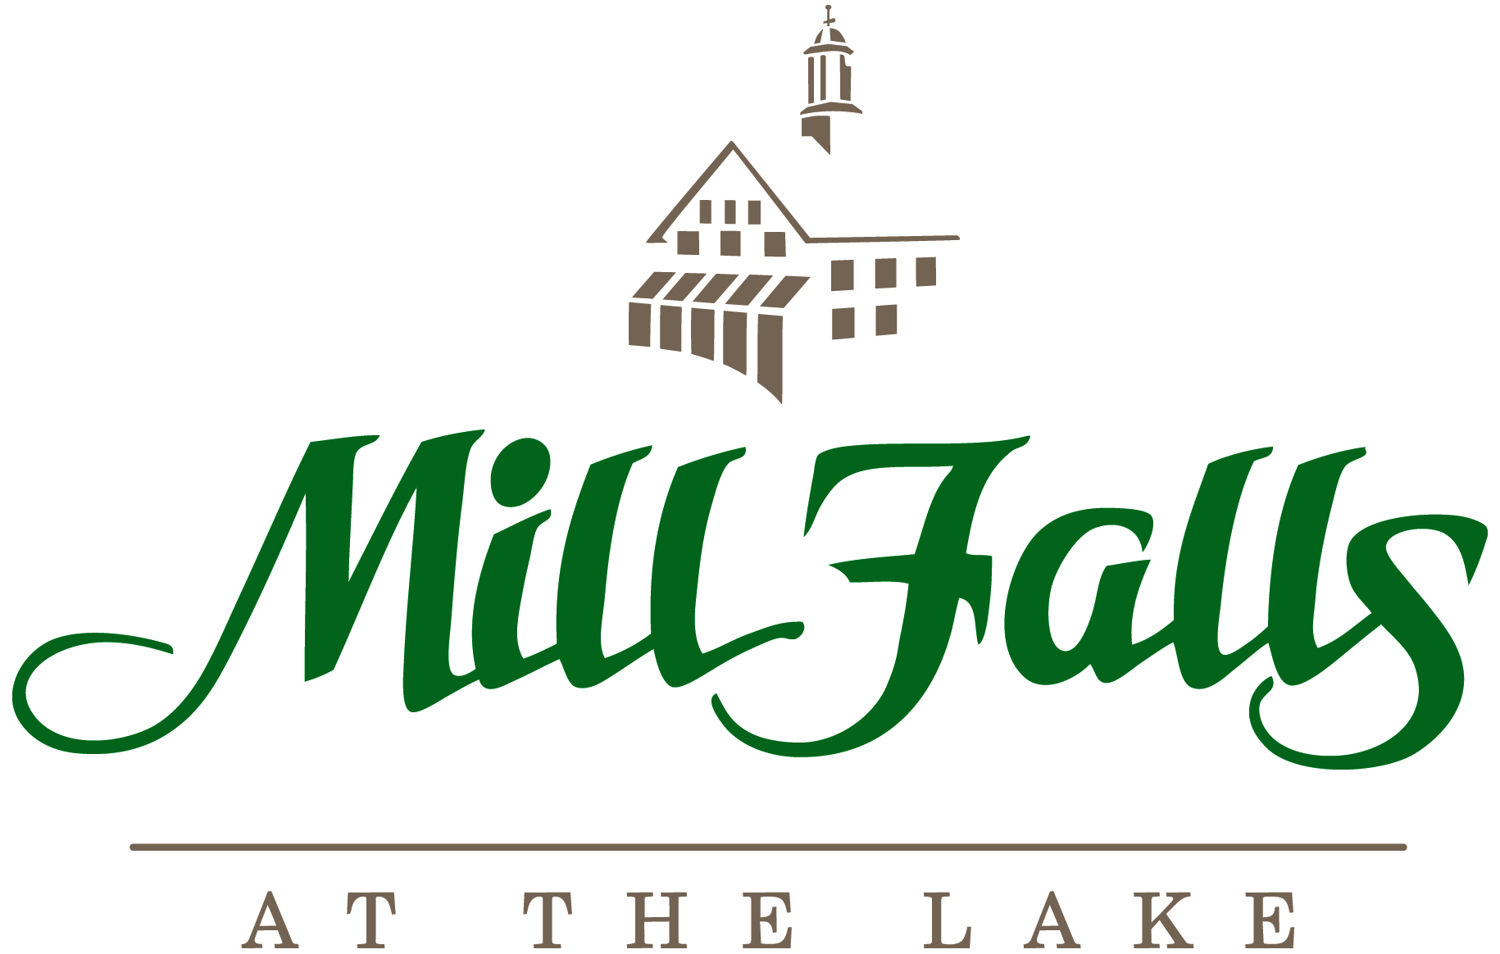

NHASEA 2019 Annual Meeting
Sunday, July 28, 2019-Wednesday, July 31, 2019

Guestroom Accommodations

Guestrooms have been held at Mill Falls, Chase House, Bay Point and Church Landing properties for this event. The conference space for 2018 is located at the Church Landing venue.

Individual guests will be paying for their own package and incidental charges.

Guests are responsible for making their own reservations.

Reservations can be made by phone at 1-800-622-6455 or via our website at www.millfalls.com.

When making a reservation attendees must identify themselves as participants of the NHASEA Annual Meeting to ensure they receive the correct rate and group placement. Rates cannot be changed upon arrival for any guests who did not identify themselves when making their reservation.

Attendees booking on line will need to enter your special GROUP CODE of 2135JX once they enter the reservation screen. Please note, guests will only be able to access those rooms as noted in the block for the specific dates outlined on your contract. Any reservations looking for an earlier arrival or later departure date along with any special room requests will need to call Mill Falls at the Lake directly at 1-800-622-6455.

Please note: As of 6/28/2019 any guestrooms being held for your event that have not been reserved will be released for sale to the general public.

PLEASE NOTE: Guests booking online will need to pay the one night package deposit when making their reservations. For those booking by phone, a deposit equivalent to one night’s package will be required no later than 7/12/2019.

Cancellation or shortening of reservation length of stay is required at least 7 days prior to arrival. If a change is needed within the 7 day time frame, we will do our best to re-sell the accommodation. If we are not successful, payment in full will be expected.

Check in time is after 3:00 PM. Check out time is by 11:00 AM. It is the responsibility of the group representative to notify all attendees of this policy to avoid confusion and inconvenience.

Baggage service is not customarily offered, due to the nature of our four separate Inns. If this service needs to be provided, arrangements must be made in advance though our Conference Coordinator.

Our goal is to provide a relaxing and enjoyable experience for all our guests as such; Quiet hours have been established as 11pm-8am. We are very serious about monitoring Guest Room and Suite disturbances. If necessary, the following actions will be taken.
- Our Security Officer and/or Manager on Duty will inform the guest that a complaint has been made and ask that the noise level be addressed.
- We will continue to monitor the area for any additional noise concerns.
- If the noise level does not diminish, we will return to the room and ask that all guests depart. If further issues arise, you may be asked to leave the property and the local Police Department may be called to assist.
- Additional fees may be incurred if other guestrooms are affected or if excessive cleaning and/or damage is caused to the room.

Package Information
The 3 Night Package (Sunday-Wednesday) includes the following:

***3 nights lodging in a Standard Room at our Mill Falls venue
***Lakeside Breakfast Buffet on Monday Morning
***Morning Beverage Break on Monday
***Assorted Gourmet Sandwiches Lunch Buffet on Monday
***Executive Continental Breakfast on Tuesday Morning
***Morning Beverage Break on Tuesday
***Bay Point Deli Lunch Buffet on Tuesday
***Assorted Breakfast Sandwiches Buffet Breakfast on Wednesday
***Morning Beverage Break on Wednesday
***South of the Border Lunch Buffet on Wednesday
***All Taxes and Gratuities associated with the package
***No alcoholic beverages are included

Single: $753.05
Double: $469.99 per person
Triple: $397.43 per person
Quad: $361.17 per person

Chase House/Bay Point Standard Room Package Rate:
Single: $916.55
Double: $551.74 per person
Triple: $451.91 per person
Quad: $402.04 per person

Church Landing Standard Room Package Rate:
Single: $1112.75
Double: $649.84 per person
Triple: $517.31 per person
Quad: $451.09 per person

The Sunday/Monday Night Package includes the following:
**Lodging on Sunday and Monday evenings in a Standard Room at our Mill Falls venue
***Lakeside Breakfast Buffet on Monday Morning
***Morning Beverage Break on Monday
***Assorted Gourmet Sandwiches Lunch Buffet on Monday
**Executive Continental Buffet Breakfast on Tuesday Morning
***Morning Beverage Break on Tuesday
***Bay Point Deli Lunch Buffet on Tuesday
***All Taxes and Gratuities associated with the package
***No alcoholic beverages are included

Single: $508.87
Double: $320.16 per person
Triple: $271.79 per person
Quad: $247.62 per person

Chase House/Bay Point Standard Room Package Rate:
Single: $617.87
Double: $374.66 per person
Triple: $308.11 per person
Quad: $274.87 per person

Church Landing Standard Room Package Rate:
Single: $748.67
Double: $440.06 per person
Triple: $351.71 per person
Quad: $307.57 per person

The Monday/Tuesday Night Package includes the following:
**Lodging on Monday and Tuesday evenings in a Standard Room at our Mill Falls venue
***Lakeside Breakfast Buffet on Monday Morning
***Morning Beverage Break on Monday
***Assorted Gourmet Sandwiches Lunch Buffet on Monday
***Executive Continental Buffet Breakfast on Tuesday Morning
***Morning Beverage Break on Tuesday
***Bay Point Deli Lunch Buffet on Tuesday
***Assorted Breakfast Sandwiches Buffet Breakfast on Wednesday Morning
***Morning Beverage Break on Wednesday
***South of the Border Lunch Buffet on Wednesday
*** All Taxes and Gratuities associated with this package
***No alcoholic beverages are included

Single: $564.34
Double: $375.63 per person
Triple: $325.97 per person
Quad: $303.09 per person

Chase House/Bay Point Standard Room Package Rate:
Single: $673.34
Double: $428.84 per person
Triple: $363.58 per person
Quad: $330.34 per person

Church Landing Standard Room Package Rate:
Single: $804.14
Double: $495.53 per person
Triple: $407.18 per person
Quad: $363.04 per person

