New Hampshire Association of Special Education Administrators
Professional Learning Opportunities Go Virtual!
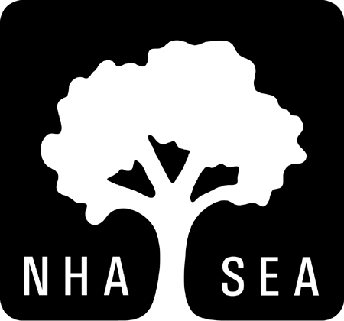
As We Embark on What Will Be a Very Unusual School Year, Join NHASEA for Some Incredible Virtual Professional Learning Opportunities
These are unprecedented times for educators. Together, everyone in the special education field must use our collective strength to overcome these new significant challenges. At NHASEA, our strengths include planning ahead and finding opportunities to support our members and their colleagues in order to persevere through these difficult times. As we re-enter a new school year, many things remain unknown, but our professional learning offerings for this year are meant to help us all evolve and grow together. Below you will find our offering for Social Emotional Learning (SEL): Thinking as we Return to Learn. If you are interested in participating in this offering, please complete the attached registration form and return dlavoie@nhasea.org or ahorrocks@nhasea.org. Thank you.
Social Emotional Learning (SEL): Thinking as we Return to Learn
Creating an environment that supports Social-Emotional Learning (SEL) allows opportunity for skill-building to thrive. In any return to school context, this can be challenging, but SEL environments are even more necessary and relevant in the unique circumstances caused by the current Covid-19 pandemic. This workshop is designed to provide participants with opportunities to think about SEL-related priorities as we try to create and settle into new routines during this very unsettled time. We’ll take some time to discuss:
- Foundational SEL Skills as well as foundational components of an SEL-Supportive environment.
- The necessity of supporting adults to model self-awareness and “well-regulated” Mind, Mood, and Body in order to provide support for students to develop their own awareness and well-regulate mindset.
- The importance of fostering connections as well as the value of establishing and embedding SEL-connected common language.
- Explore ways to promote self-awareness through self-assessment, and self-regulation through regulation strategies.
Facilitator: Eric Mann, MSE, SEL Consultant at SERESC
Date and Time: September 30, 2020 at 10:00 a.m. to 12:00 p.m.
Cost: $150.00 for Members; $200.00 for non-members
Social Emotional Learning (SEL): Thinking as we Return to Learn
Virtual Platform
DATE

Name: ________________________________________________________________
Position: ______________________________________________________________
Home Address: _________________________________________________________
City: ___________________ State: ___________ Zip Code: ___________________
Email: ________________________________________________________________
Work Phone: _________________ Fax: ___________________Cell: ______________

______ $150.00 per person (Member)
______ $200.00 per person (Non-Member)

Please bill with P.O. # ____________________________
Check is enclosed for $ ___________________________
Credit card payment _____________________________
Make Check Payable to: NHASEA
25 Triangle Park Drive, Suite 103
Concord, NH 03301

Fax: 224-0684 or Email: dlavoie@nhasea.org or ahorrocks@nhasea.org

Cancellation Clause: If attendee cannot attend, a refund will not be given. Only in the case of someone who has registered and paid, will someone else be allowed to attend in their absence.

